Before attaching any rotors or camera

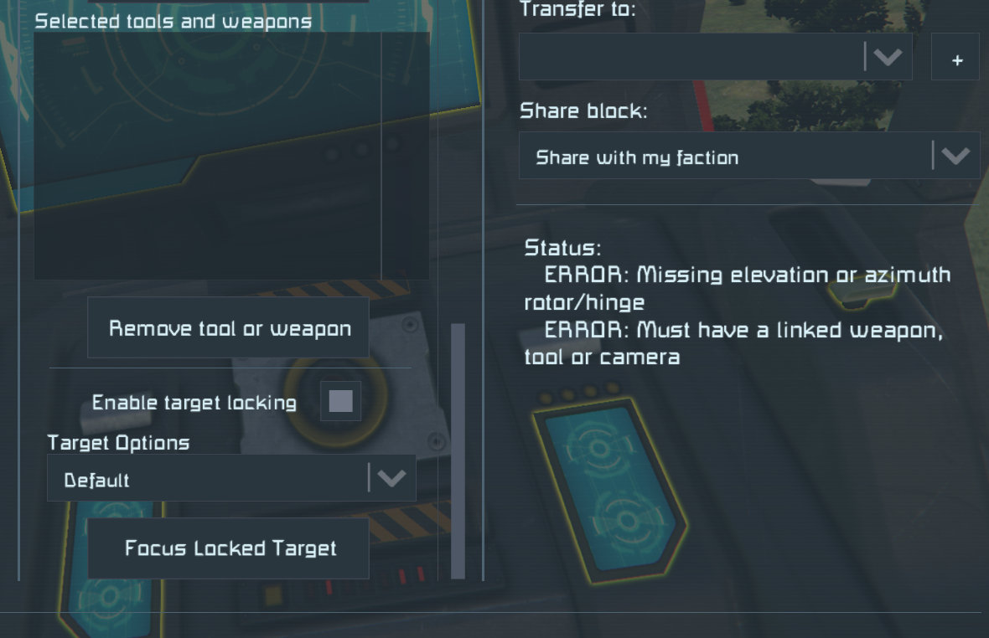

With Rotors assigned

With a random camera assigned

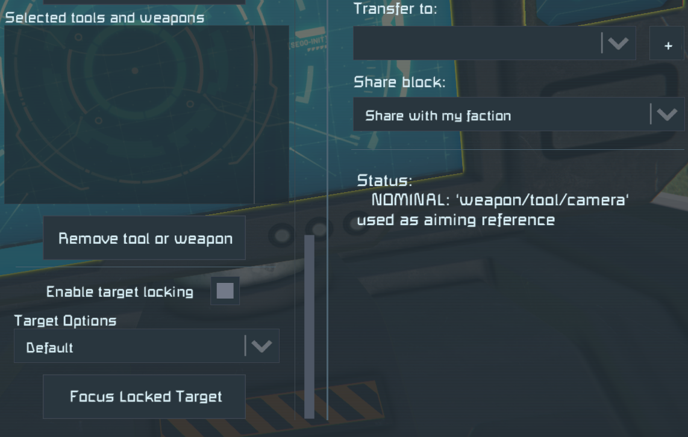

After changing assigned camera

