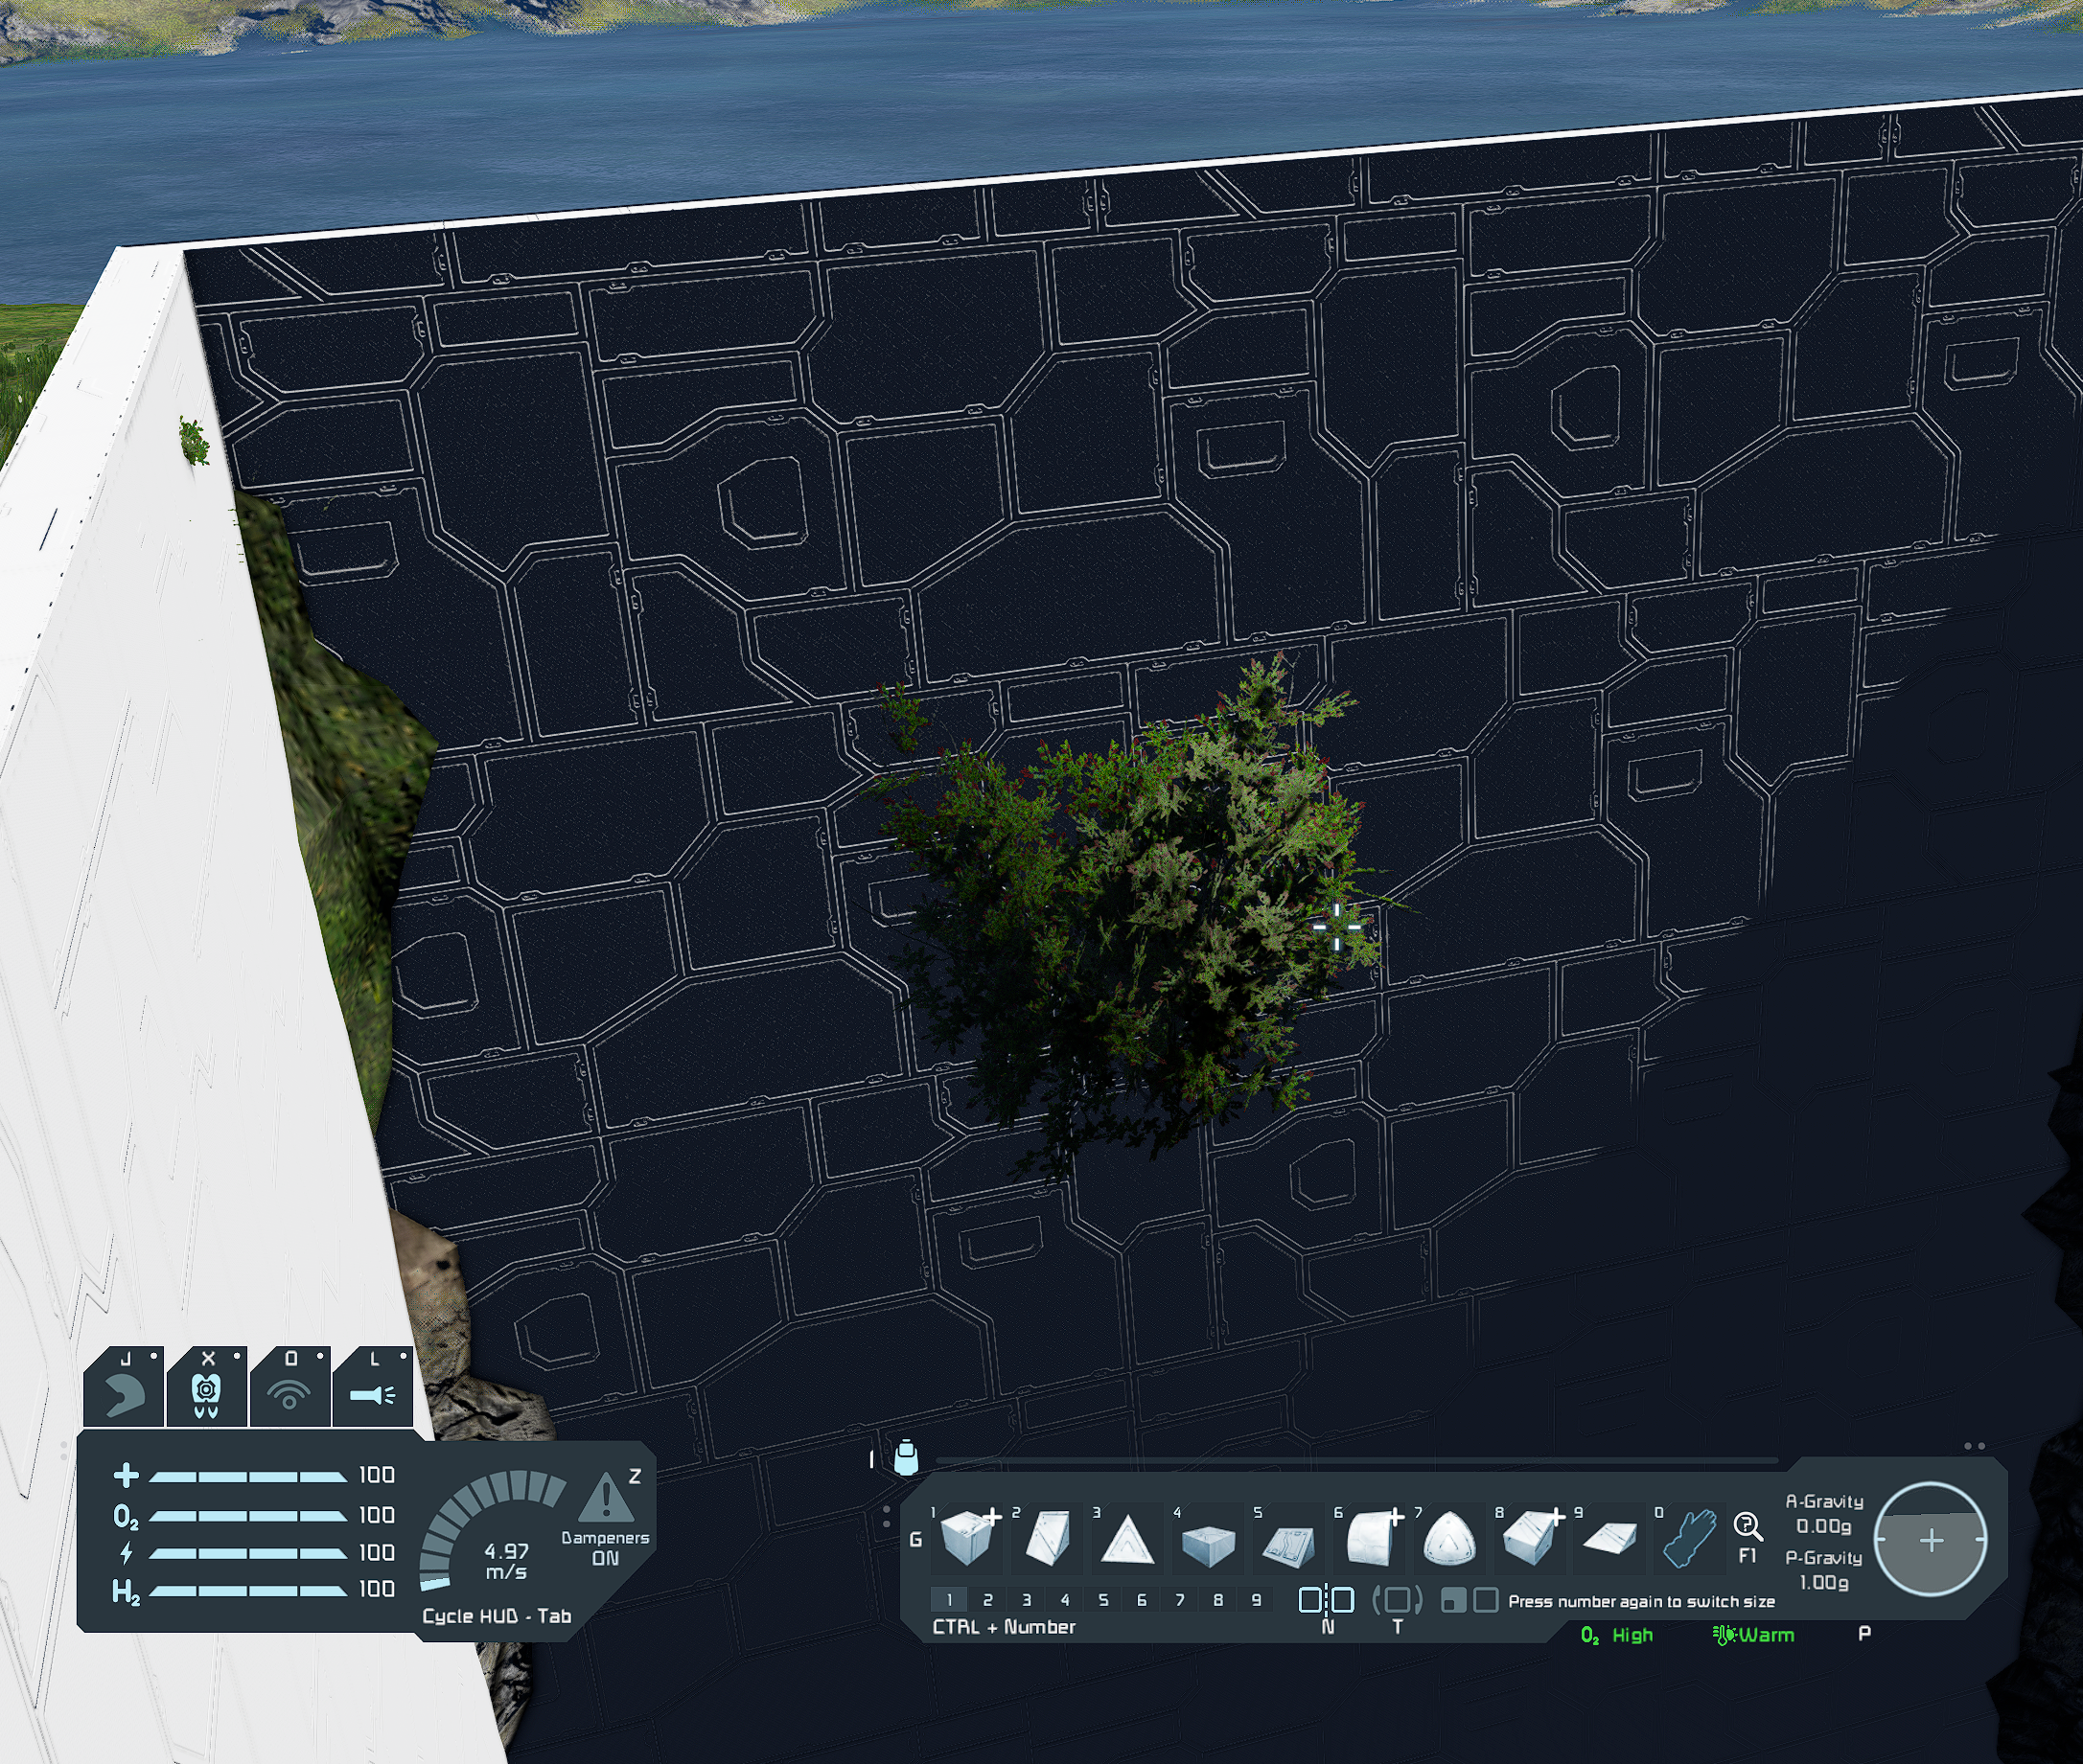
Why are the bushes in the air?

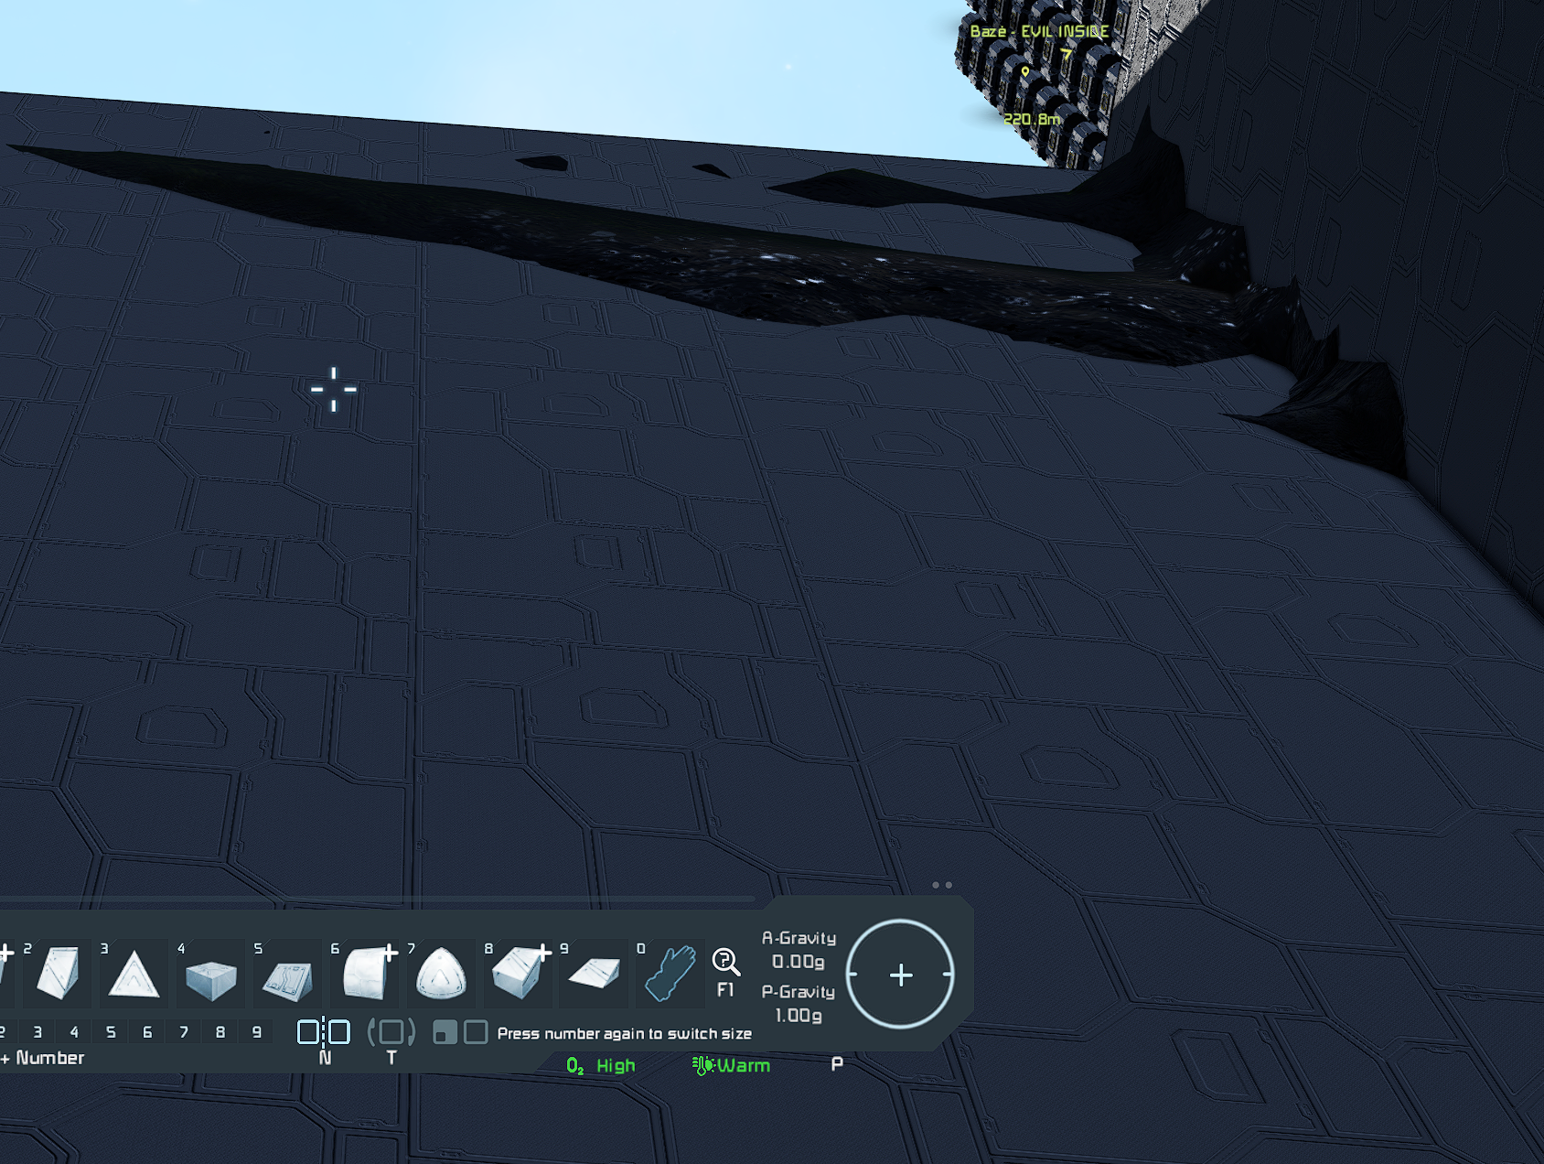
Why do textures stick out where they shouldn't stick out?
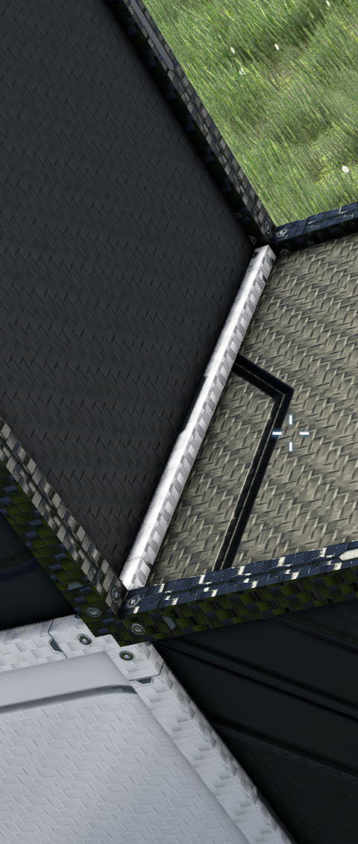
Regarding the previous complaint and its consequences, you paint half of the details, leave half unpainted, and then you have those misunderstandings that arise when a place has to be painted in one color, there is a part of the contour left unpainted.
If you are already coloring a detail, it must be completely colored and not half colored and half left.

